**Control chart Patterns Recognition Using Convolutional Neural Network**

**Data Visualization**

I have taken a random hypothetical time series data in which length and breadth varying day to day as shown in the table below:

|  |  |  |
| --- | --- | --- |
| Date | length | width |
| 7/1/2020 | 12 | 13 |
| 7/2/2020 | 13 | 14 |
| 7/3/2020 | 15 | 14 |
| 7/4/2020 | 16 | 15 |
| 7/5/2020 | 13 | 12 |
| 7/6/2020 | 12 | 13 |
| 7/7/2020 | 15 | 14 |
| 7/8/2020 | 18 | 17 |
| 7/9/2020 | 14 | 15 |
| 7/10/2020 | 12 | 13 |
| 7/11/2020 | 13 | 14 |
| 7/12/2020 | 11 | 12 |
| 7/13/2020 | 13 | 12 |
| 7/14/2020 | 14 | 13 |
| 7/15/2020 | 16 | 17 |
| 7/16/2020 | 15 | 16 |
| 7/17/2020 | 16 | 17 |
| 7/18/2020 | 13 | 12 |
| 7/19/2020 | 12 | 13 |
| 7/20/2020 | 15 | 14 |

From the above data we can find the mean and standard deviation and use this for data simulation.I have made various control chart patterns having different patterns using Data Simulation (**Monte carlo Simulation**) by changing various parameters for each patterns as shown in the table below:

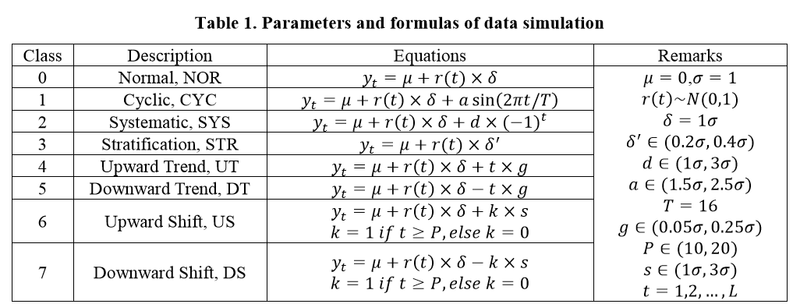

So from the above table we get the equation for each pattern and make datasets for each pattern.

Thus we can make datasets for each pattern by monte carlo simulation.

Now I have put all these datasets in one csv file and used these datasets (see ccps_dataset) for training our models .

1. **Normal Pattern**

|  |  |  |
| --- | --- | --- |
| Date | length | width |
| 7/1/2020 | 14.41736499 | 14.85319011 |
| 7/2/2020 | 15.1390215 | 15.04079638 |
| 7/3/2020 | 14.95287652 | 14.59983935 |
| 7/4/2020 | 14.14824577 | 14.15264293 |
| 7/5/2020 | 14.55647575 | 15.00158239 |
| 7/6/2020 | 15.28380156 | 15.29834488 |
| 7/7/2020 | 15.13852712 | 13.92839681 |
| 7/8/2020 | 14.14080498 | 14.65408617 |
| 7/9/2020 | 15.2835032 | 14.80189216 |
| 7/10/2020 | 15.68019054 | 13.98443528 |
| 7/11/2020 | 15.14604731 | 14.48552083 |
| 7/12/2020 | 13.90146553 | 14.18844898 |
| 7/13/2020 | 14.18003568 | 15.1521964 |
| 7/14/2020 | 15.55650582 | 14.18049978 |
| 7/15/2020 | 14.97198136 | 14.05166489 |
| 7/16/2020 | 14.71089656 | 13.96586324 |
| 7/17/2020 | 15.36432788 | 14.45174549 |
| 7/18/2020 | 14.45977442 | 14.50660244 |
| 7/19/2020 | 15.16995596 | 14.57385084 |
| 7/20/2020 | 15.54230371 | 13.98989966 |

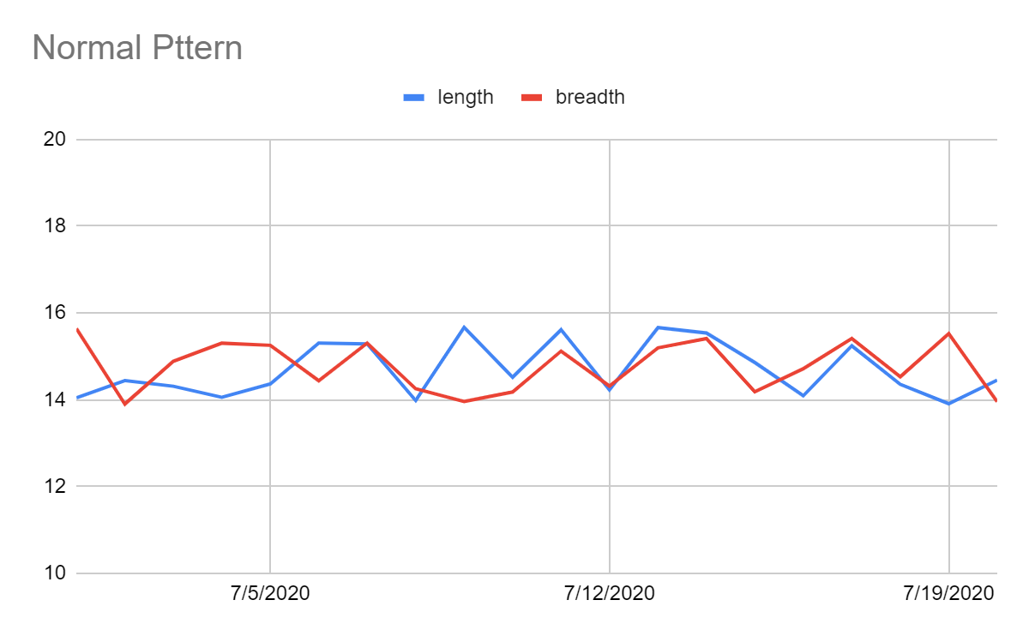

1. **Cyclic Patterns**

|  |  |  |
| --- | --- | --- |
| Date | length | width |
| 7/1/2020 | 16.57686131 | 16.51473633 |
| 7/2/2020 | 15.67524719 | 17.07787604 |
| 7/3/2020 | 15.96527086 | 17.54036986 |
| 7/4/2020 | 16.75485569 | 18.23235707 |
| 7/5/2020 | 18.46535876 | 18.23957559 |
| 7/6/2020 | 18.73631776 | 19.39870278 |
| 7/7/2020 | 18.42451372 | 17.53908831 |
| 7/8/2020 | 19.42268044 | 16.68439151 |
| 7/9/2020 | 18.55326123 | 16.87921776 |
| 7/10/2020 | 18.31774383 | 14.25905183 |
| 7/11/2020 | 18.76468822 | 14.05287012 |
| 7/12/2020 | 17.96146102 | 12.16416673 |
| 7/13/2020 | 17.7930749 | 12.02720791 |
| 7/14/2020 | 17.98694101 | 11.5875398 |
| 7/15/2020 | 18.32067927 | 11.48669344 |
| 7/16/2020 | 16.28714682 | 10.55583677 |
| 7/17/2020 | 17.09987151 | 10.75535256 |
| 7/18/2020 | 16.46471205 | 12.41876039 |
| 7/19/2020 | 15.81095747 | 14.04001648 |
| 7/20/2020 | 13.93038927 | 14.29430769 |

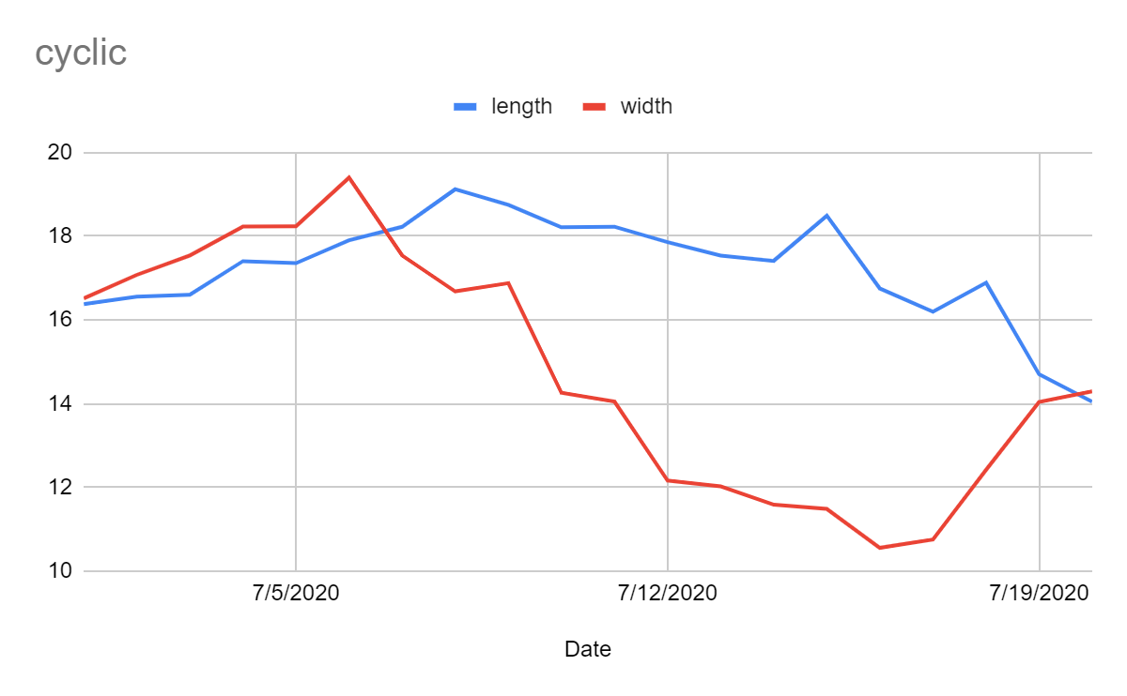

1. **Stratification Pattern**

|  |  |  |
| --- | --- | --- |
| Date | length | width |
| 7/1/2020 | 14.00668084 | 14.19329888 |
| 7/2/2020 | 14.07878054 | 14.00314548 |
| 7/3/2020 | 14.31822426 | 14.38252786 |
| 7/4/2020 | 14.04217957 | 14.1227238 |
| 7/5/2020 | 14.42026152 | 13.93892563 |
| 7/6/2020 | 13.99276894 | 14.15781979 |
| 7/7/2020 | 14.21088435 | 14.02493488 |
| 7/8/2020 | 14.06708536 | 14.34175604 |
| 7/9/2020 | 14.38812132 | 14.11201702 |
| 7/10/2020 | 14.23779182 | 14.19862562 |
| 7/11/2020 | 14.32663758 | 13.92399552 |
| 7/12/2020 | 14.42815822 | 14.35030012 |
| 7/13/2020 | 14.37833845 | 13.93243282 |
| 7/14/2020 | 14.09006055 | 14.25459107 |
| 7/15/2020 | 14.30245558 | 14.12140077 |
| 7/16/2020 | 14.18653029 | 14.1662792 |
| 7/17/2020 | 14.24653696 | 14.39376866 |
| 7/18/2020 | 13.95004483 | 14.42843939 |
| 7/19/2020 | 13.93873332 | 14.12683218 |
| 7/20/2020 | 13.94002687 | 14.26647275 |

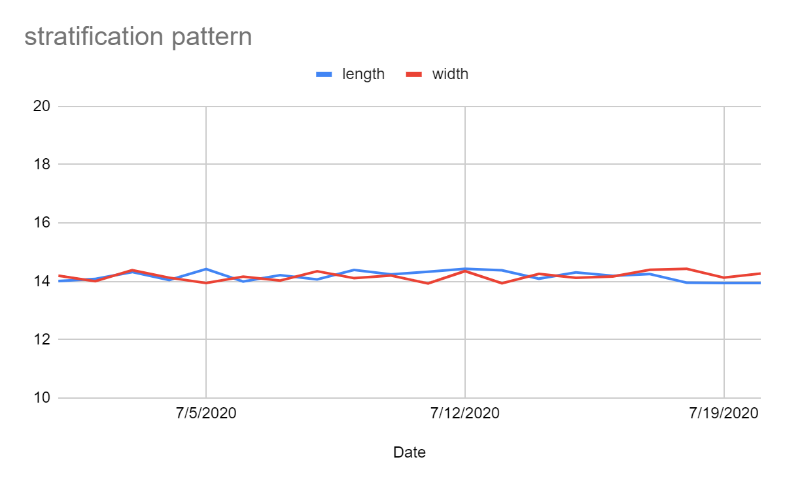

1. **Systematic Patterns**

|  |  |  |
| --- | --- | --- |
| Date | length | width |
| 7/1/2020 | 10.43540225 | 10.58243259 |
| 7/2/2020 | 19.26353856 | 17.84367456 |
| 7/3/2020 | 10.85827025 | 10.96919035 |
| 7/4/2020 | 18.61982232 | 17.68276223 |
| 7/5/2020 | 11.5381143 | 11.35646015 |
| 7/6/2020 | 18.62263878 | 18.30783033 |
| 7/7/2020 | 10.50589859 | 10.50126965 |
| 7/8/2020 | 17.65916976 | 18.30542409 |
| 7/9/2020 | 10.38767579 | 11.96063328 |
| 7/10/2020 | 18.21797622 | 18.73823149 |
| 7/11/2020 | 11.12702272 | 12.02896554 |
| 7/12/2020 | 19.12509491 | 17.98680963 |
| 7/13/2020 | 11.49567475 | 12.03284756 |
| 7/14/2020 | 17.94172923 | 19.03179306 |
| 7/15/2020 | 12.09448926 | 11.32776983 |
| 7/16/2020 | 19.13637666 | 18.0179678 |
| 7/17/2020 | 12.04451235 | 11.58948194 |
| 7/18/2020 | 17.81191684 | 18.62505776 |
| 7/19/2020 | 11.48053852 | 10.89926949 |
| 7/20/2020 | 18.0777396 | 18.72895551 |

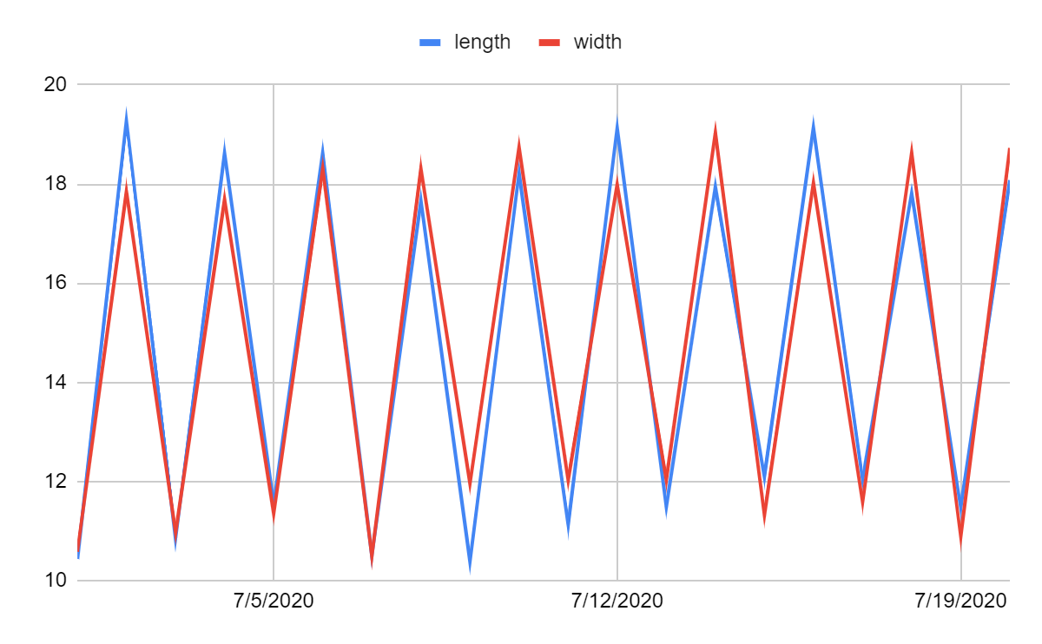

1. **Upshift Patterns**

|  |  |  |
| --- | --- | --- |
| Date | length | breadth |
| 7/1/2020 | 15.55323379 | 14.76051212 |
| 7/2/2020 | 14.38593562 | 14.76139048 |
| 7/3/2020 | 14.45310583 | 14.84295263 |
| 7/4/2020 | 14.99758865 | 14.97513358 |
| 7/5/2020 | 14.26307346 | 15.28185925 |
| 7/6/2020 | 14.95479842 | 15.39921221 |
| 7/7/2020 | 14.80052322 | 15.23197451 |
| 7/8/2020 | 15.0576156 | 13.902792 |
| 7/9/2020 | 15.24610909 | 14.48290316 |
| 7/10/2020 | 14.93209175 | 15.18376216 |
| 7/11/2020 | 19.6537452 | 19.73494256 |
| 7/12/2020 | 19.60448259 | 20.02884463 |
| 7/13/2020 | 19.48426414 | 20.05016484 |
| 7/14/2020 | 19.82611764 | 19.00221165 |
| 7/15/2020 | 19.52785143 | 19.23092249 |
| 7/16/2020 | 19.98254503 | 18.91992795 |
| 7/17/2020 | 20.13139088 | 19.14611048 |
| 7/18/2020 | 20.24807522 | 19.72487484 |
| 7/19/2020 | 20.04223602 | 19.10441165 |
| 7/20/2020 | 19.86247248 | 20.56463607 |

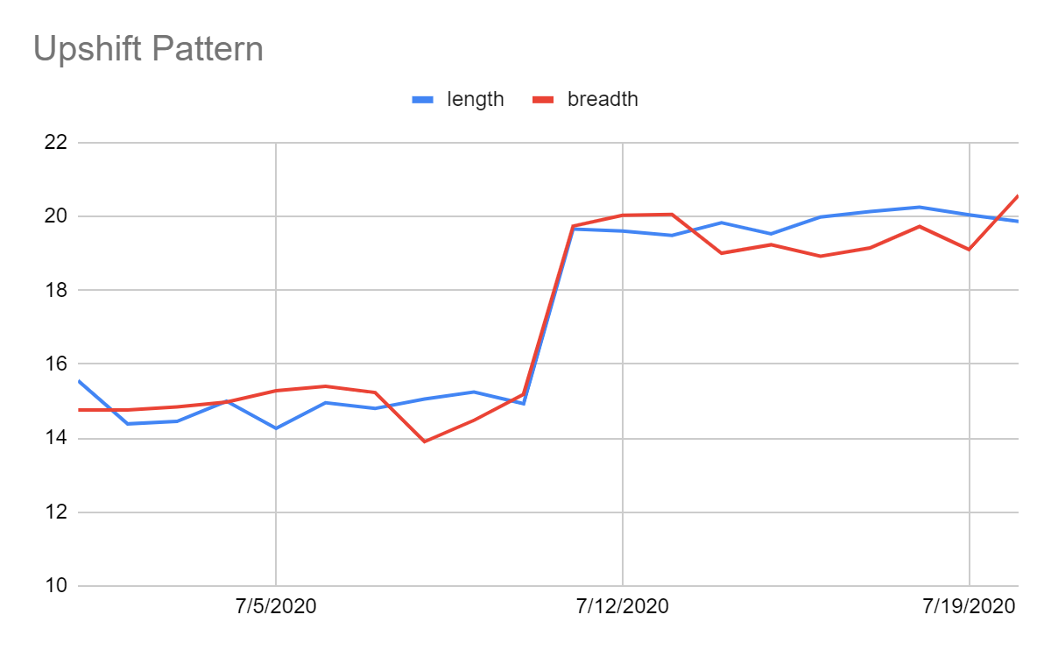

1. **Downshift Pattern**

|  |  |  |
| --- | --- | --- |
| Date | length | width |
| 7/1/2020 | 15.16450435 | 14.44213472 |
| 7/2/2020 | 13.96832645 | 14.71376864 |
| 7/3/2020 | 15.61293779 | 15.18314543 |
| 7/4/2020 | 14.68244684 | 15.392055 |
| 7/5/2020 | 15.34179973 | 14.56748363 |
| 7/6/2020 | 14.58453543 | 14.40798398 |
| 7/7/2020 | 14.62481546 | 14.32946906 |
| 7/8/2020 | 13.96547986 | 14.83449516 |
| 7/9/2020 | 14.91061385 | 14.85465808 |
| 7/10/2020 | 14.70720042 | 15.46226467 |
| 7/11/2020 | 14.64042627 | 13.99592633 |
| 7/12/2020 | 9.081128506 | 10.7939706 |
| 7/13/2020 | 9.724009253 | 9.775047043 |
| 7/14/2020 | 9.144910576 | 9.253913729 |
| 7/15/2020 | 9.214269418 | 9.91271225 |
| 7/16/2020 | 10.74336538 | 10.19005585 |
| 7/17/2020 | 10.3439698 | 9.339696698 |
| 7/18/2020 | 10.60858774 | 10.51533897 |
| 7/19/2020 | 10.18976318 | 9.893822252 |
| 7/20/2020 | 9.978158857 | 9.734550799 |

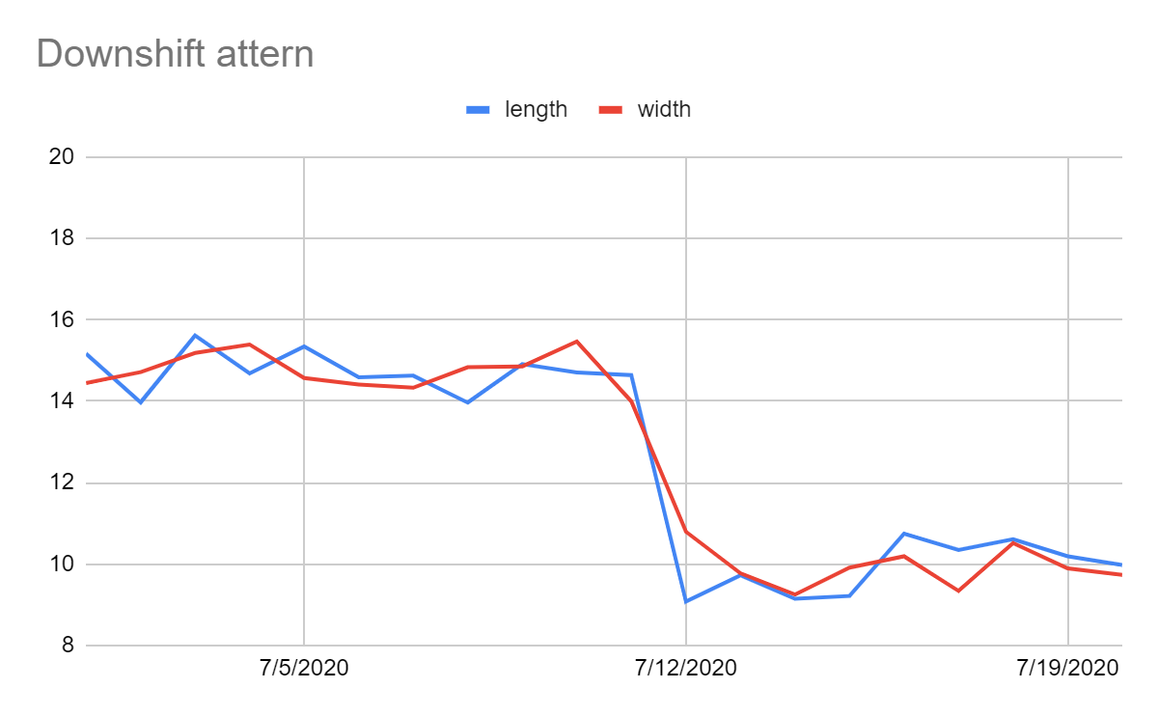

1. **Uptrend Pattern**

|  |  |  |
| --- | --- | --- |
| Date | length | width |
| 7/1/2020 | 15.64286384 | 14.63030453 |
| 7/2/2020 | 15.13220702 | 16.11608387 |
| 7/3/2020 | 14.91969075 | 15.71290983 |
| 7/4/2020 | 16.64106039 | 16.70524384 |
| 7/5/2020 | 17.16533655 | 17.18980791 |
| 7/6/2020 | 16.81853575 | 16.84847956 |
| 7/7/2020 | 16.36689493 | 16.87143552 |
| 7/8/2020 | 17.43466498 | 18.10545153 |
| 7/9/2020 | 16.69403766 | 17.48518235 |
| 7/10/2020 | 18.43221024 | 18.03324149 |
| 7/11/2020 | 18.37862411 | 18.97996999 |
| 7/12/2020 | 18.64534244 | 19.02264284 |
| 7/13/2020 | 18.05308813 | 19.20571019 |
| 7/14/2020 | 19.35597204 | 18.20682189 |
| 7/15/2020 | 19.89542364 | 19.67977721 |
| 7/16/2020 | 19.39675541 | 20.06474878 |
| 7/17/2020 | 19.75103832 | 20.53892181 |
| 7/18/2020 | 20.15643522 | 19.47091875 |
| 7/19/2020 | 20.53950792 | 20.63076887 |
| 7/20/2020 | 21.09379049 | 21.29245819 |

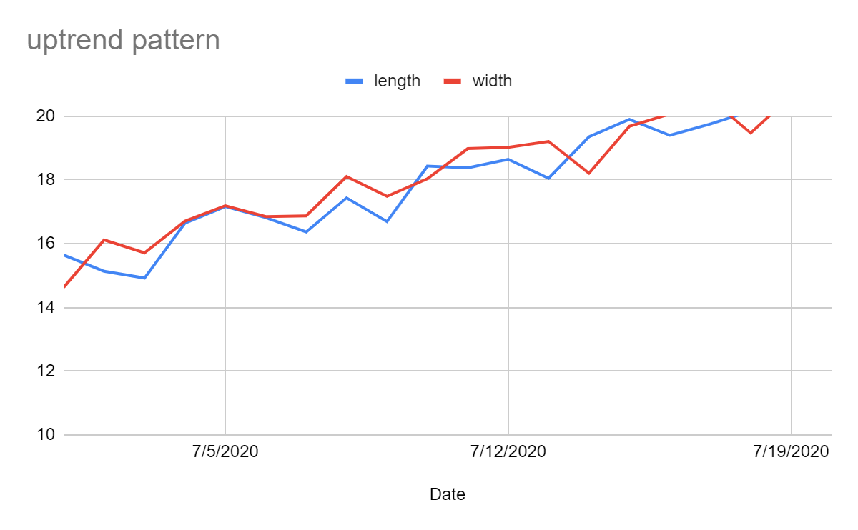

1. **Downtrend Patterns**

|  |  |  |
| --- | --- | --- |
| Date | length | beadth |
| 7/1/2020 | 14.13702217 | 13.76628637 |
| 7/2/2020 | 13.61518391 | 13.38880287 |
| 7/3/2020 | 14.00603108 | 12.99886714 |
| 7/4/2020 | 13.56632906 | 13.14554758 |
| 7/5/2020 | 13.33847331 | 14.12352681 |
| 7/6/2020 | 12.60117698 | 13.73594816 |
| 7/7/2020 | 12.24171077 | 11.99388573 |
| 7/8/2020 | 13.0581362 | 12.22172758 |
| 7/9/2020 | 11.70178225 | 12.03291275 |
| 7/10/2020 | 12.38064875 | 11.28964706 |
| 7/11/2020 | 12.31116267 | 10.80095316 |
| 7/12/2020 | 11.21896211 | 10.22836243 |
| 7/13/2020 | 11.36068019 | 10.38319929 |
| 7/14/2020 | 11.14780868 | 9.712709424 |
| 7/15/2020 | 10.63134058 | 9.362221954 |
| 7/16/2020 | 9.250174254 | 9.534957716 |
| 7/17/2020 | 9.561306573 | 10.36315361 |
| 7/18/2020 | 9.006850027 | 9.393901321 |
| 7/19/2020 | 8.329144766 | 9.653560318 |
| 7/20/2020 | 8.840624377 | 9.243587638 |

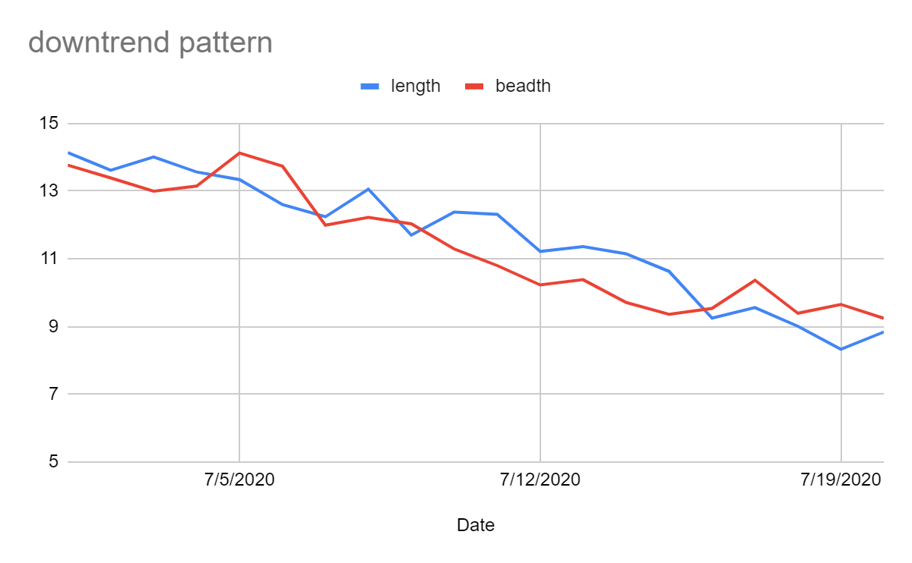

**Results**

I have trained the datasets (CCPs_dataset) on three models:

1. ANN
2. Simple 1-D CNN
3. Improved 1-D CNN (having inception layer)

And test these models on test datasets and compare the accuracy of these three model.

1. **Accuracy**

|  |  |  |  |
| --- | --- | --- | --- |
| **Model** | ANN | 1L-1D CNN | Improved 1-D CNN |
| **Accuracy** | 0.50 | 0.588 | 0.6544 |

1. **Confusion matrix**

ANN

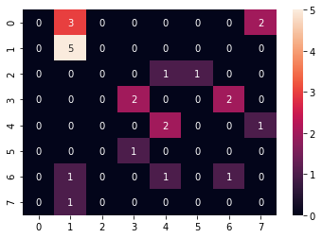

1 layer 1-D CNN

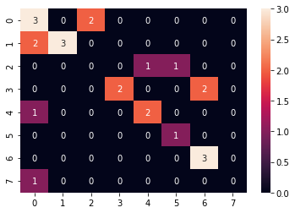

Improved 1-D CNN

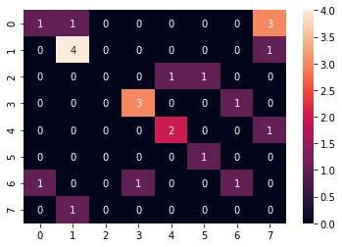

1. **Graph between training and validation loss of Models per epoch:**
2. ANN

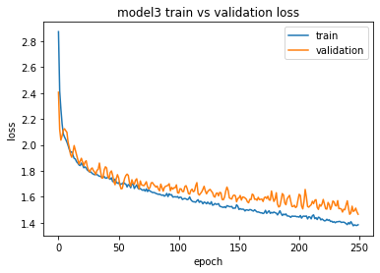

B. 1 layer 1-D CNN

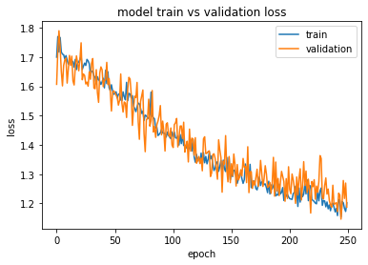

C. Improved 1-D CNN ( having inception layer)

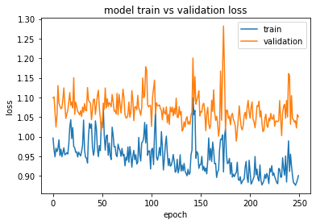

**4. Graph between accuracy of 1layer 1-d(model 1) cnn and Improved 1-D CNN(model2) per epoch**

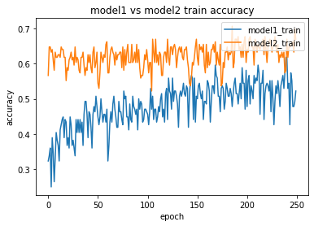

From above plots, confusion matrix and accuracy of each data we can clearly conclude that the improved 1-D CNN model obtained better recognition accuracy than other two models .